CUES© Parent Group
Coping with Uncertainty in Everyday Situations for Parents of Autistic Children

Highwood Primary School | Mondays
| 09:15-11:15 | Starting 13th January 2025 |
| 8 weeks (excluding half term) |
Parenting is probably the hardest job you will ever do and having an autistic child who struggles with uncertainty comes with its own challenges. Are you:
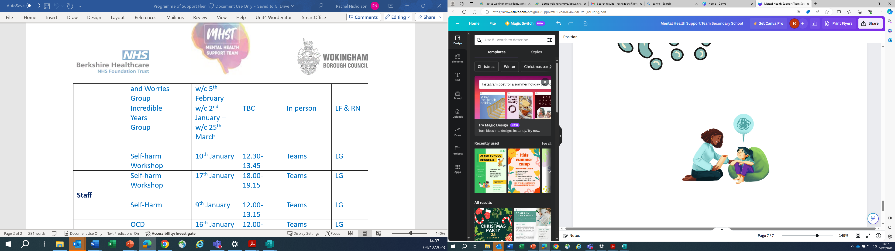
- The parent/carer of a child in Year 2, 3 or 4 with an ASC diagnosis (or on the pathway for assessment)?
- Does your child struggle with new or uncertain situations?
- Would you like to help your child tolerate uncertainty more effectively?
- Would you like to meet other parents with similar difficulties?

Why not attend our friendly CUES© parent course!

- Access the course by completing the referral form available from your school and emailing it to mhstadmin@wokingham.gov.uk by Friday 6th December stating how many parent/carers wish to attend the course, and a friendly course facilitator will be in touch to arrange an introductory phone call.

