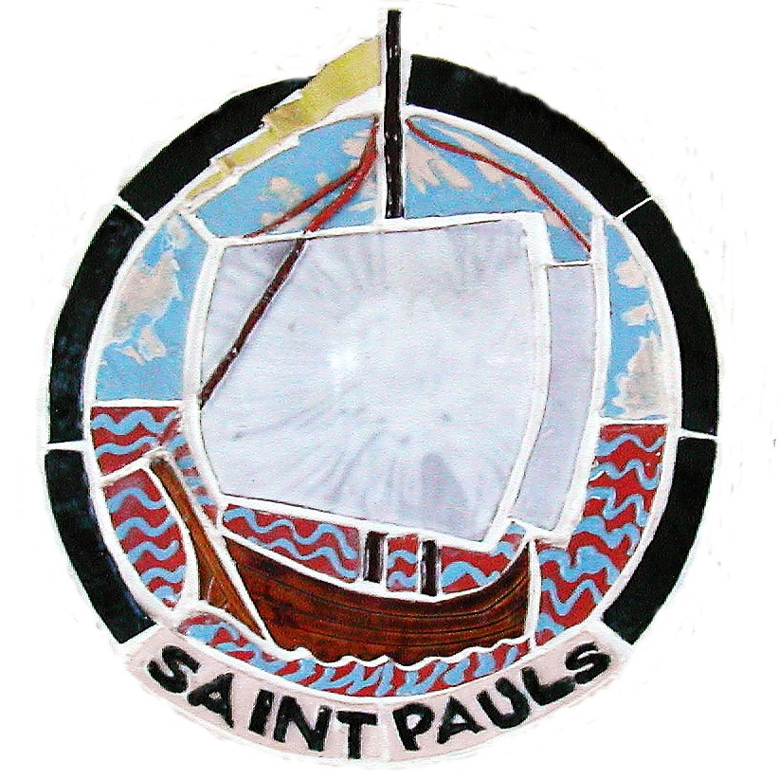 | St Paul’s C of E Junior School  Oxford Road, Wokingham, RG41 2YJ  Tel: (0118) 978 5219  Email: office@stpauls.wokingham.sch.uk  Website: www.stpauls.wokingham.sch.uk  Headteacher: Mrs J M Taylor

ALLERGY PHOTO CONSENT

I confirm that I am happy for the kitchen to display a ‘Food Allergy Record Sheet’ and a photo of my child on the kitchen wall near the servery.

Child’s Name: ………………………………………………………… Child’s Class: ………………………………………………

Parent’s Name: ………………………………………………… Parent’s Signature ……………………………………

Date: ……………………

